All necessary installers and guides can be found at:

<https://github.com/danielaoliveira/FIRMA-UserStudy-UF>

Download:

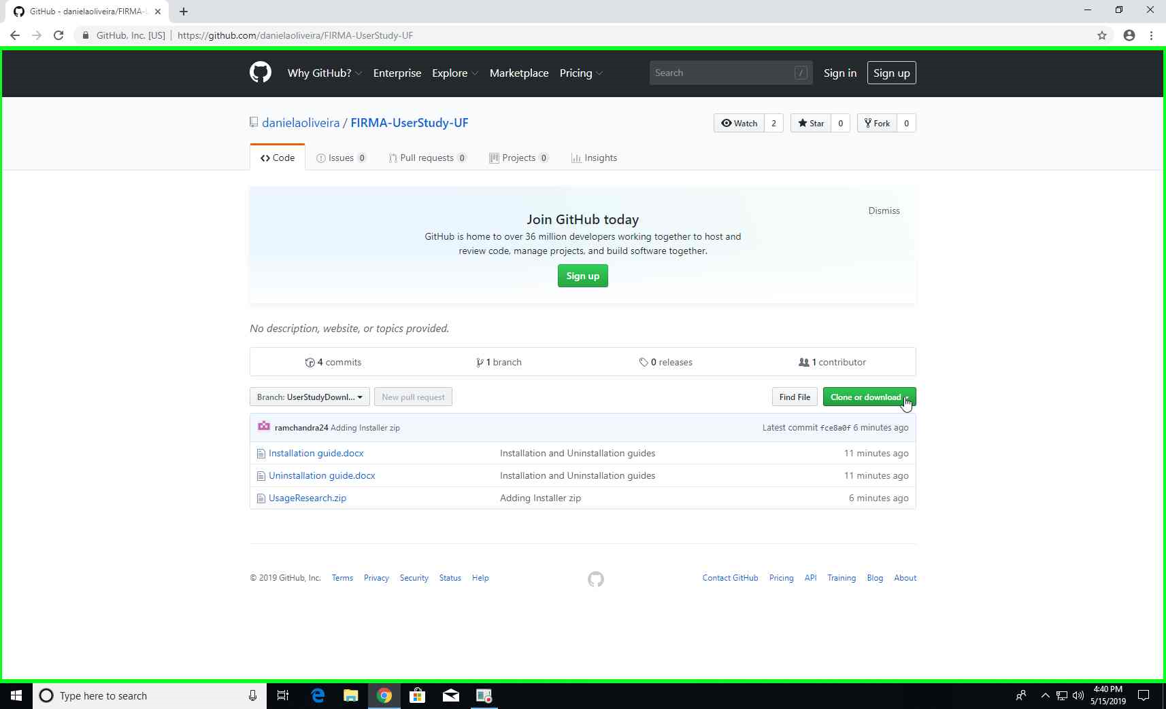

Step 1: Open the link in a browser

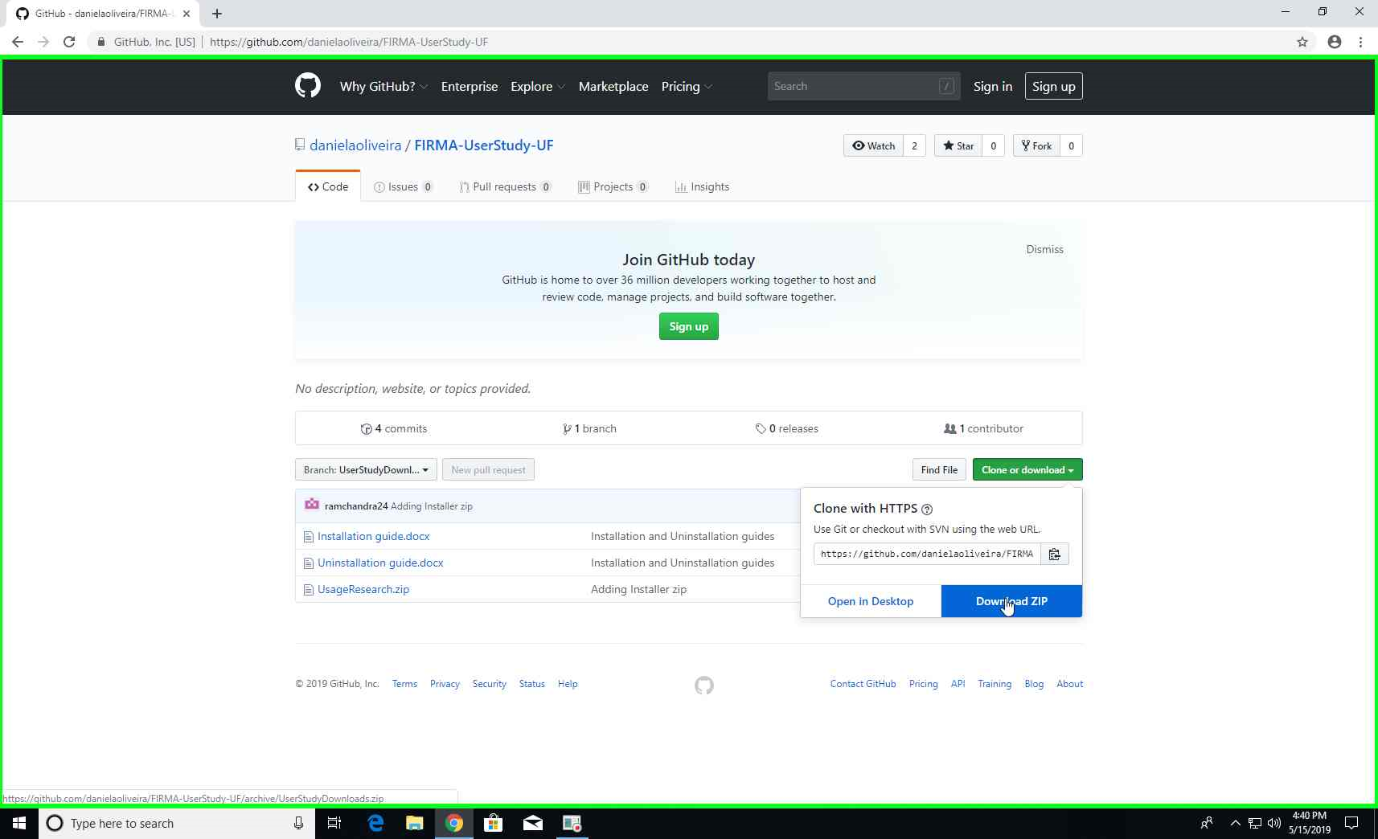

Step 2: Click on “Clone or download” and then select “Download ZIP”

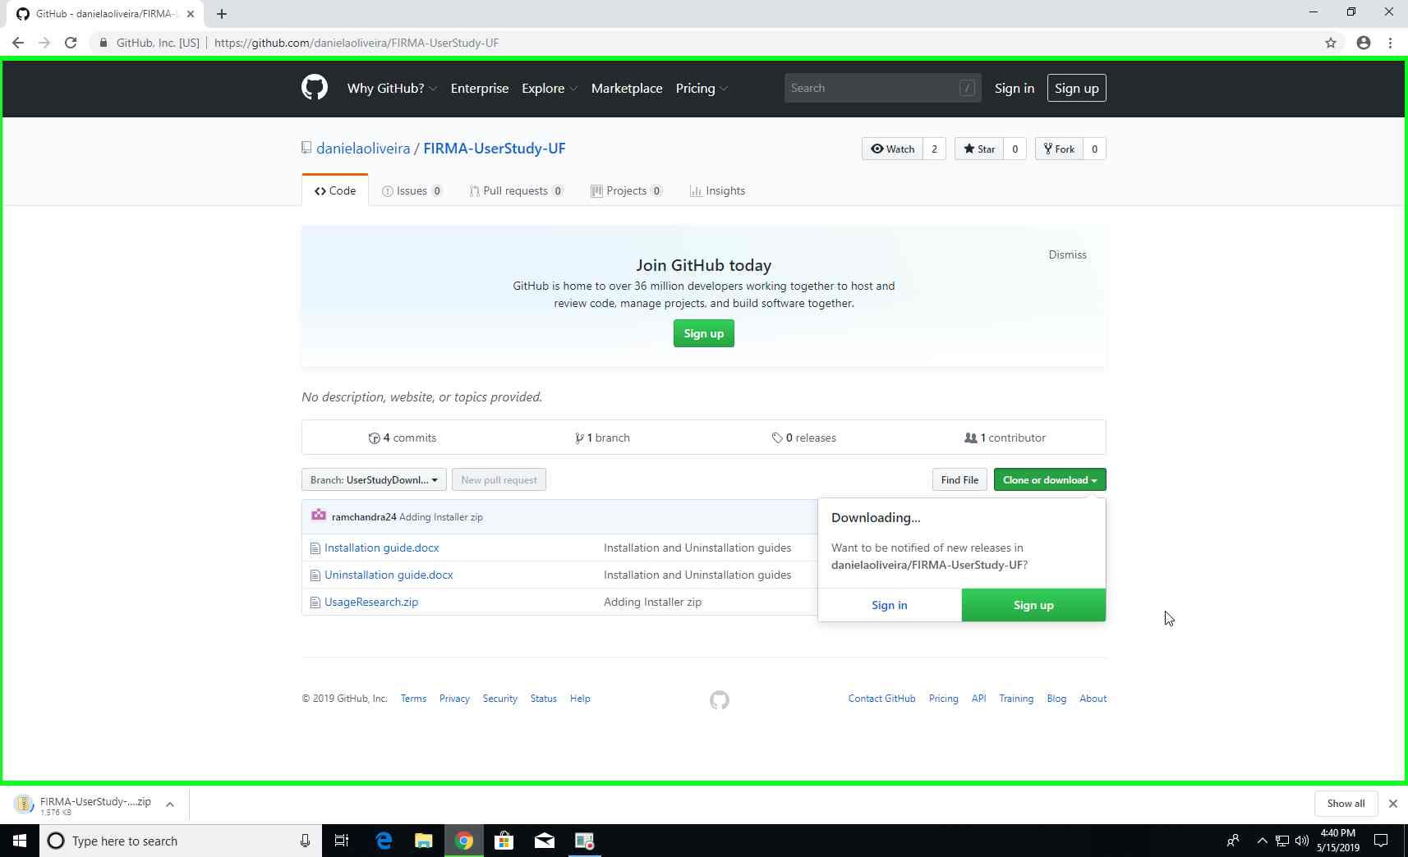

Step 3: Zip containing installers and instructions is downloaded

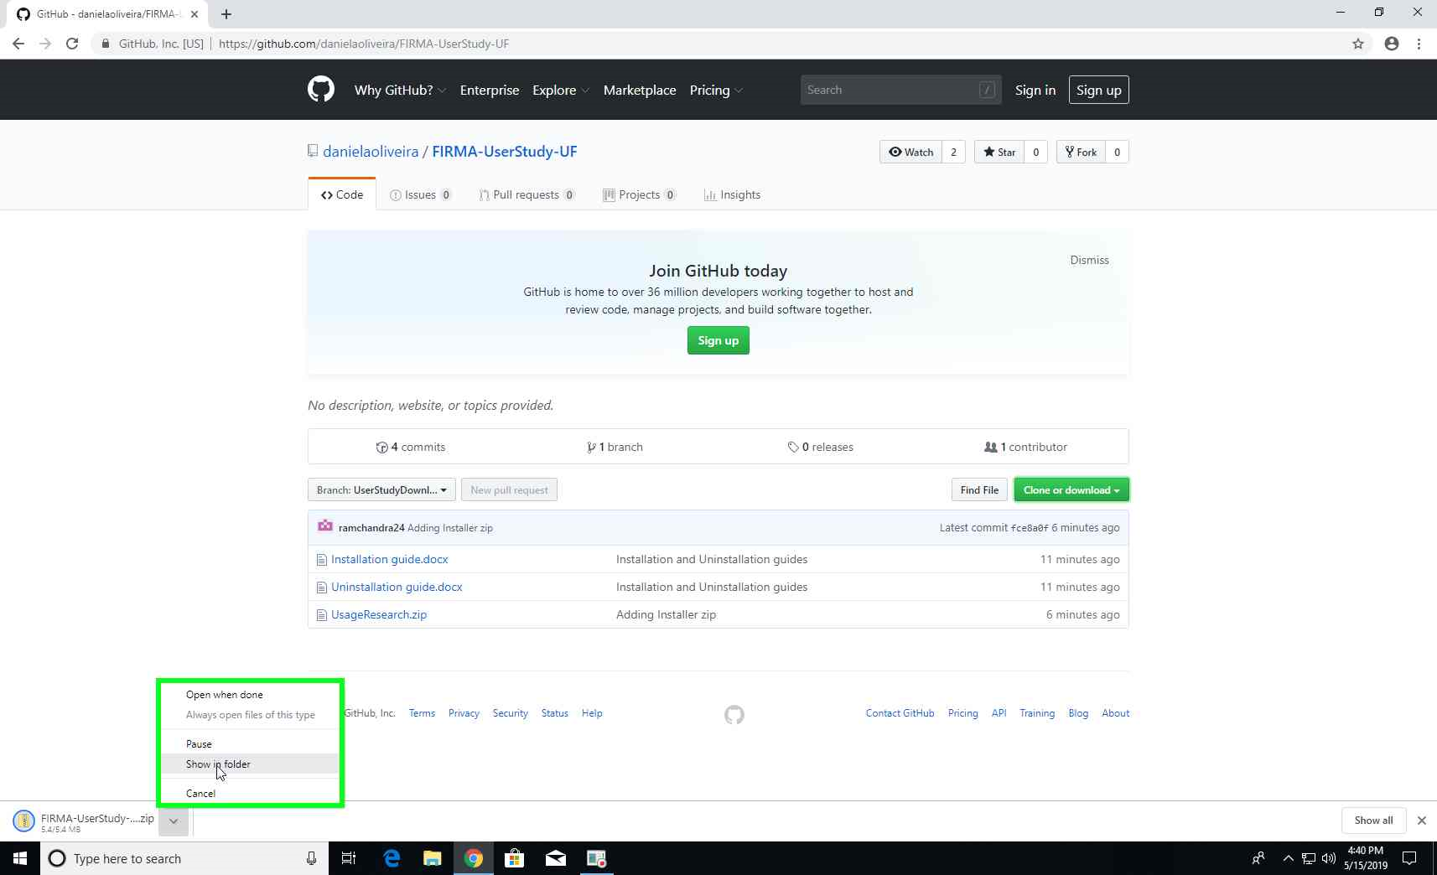

Step 4: Once the zip is successfully downloaded, open the folder where the file is downloaded

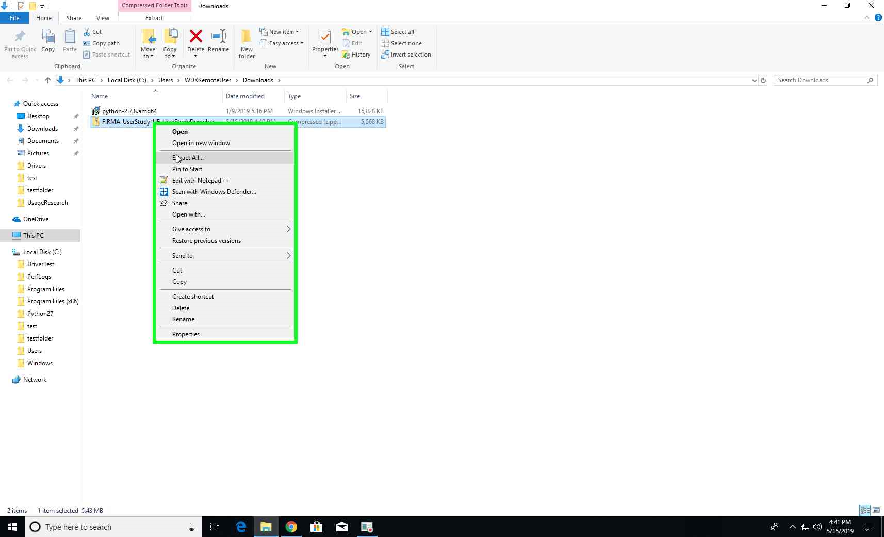

Step 5: Extract the contents of the downloaded file

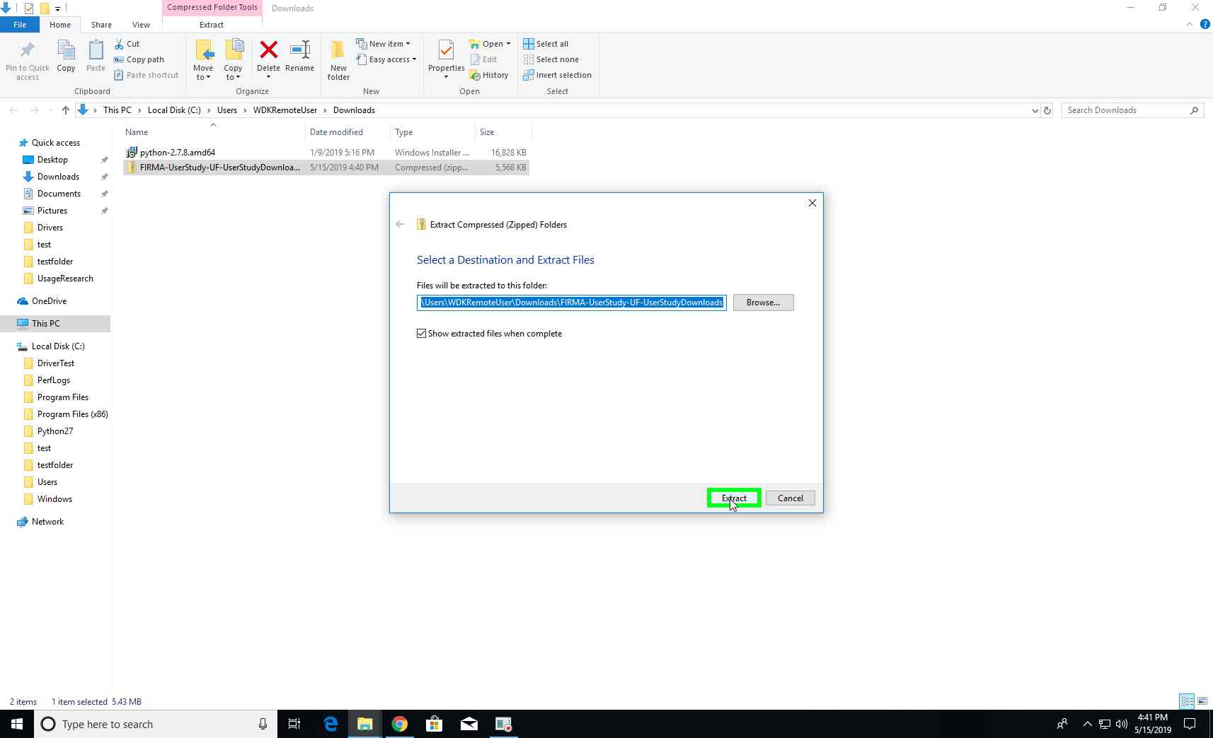

Step 6: Choose a folder where the contents can be extracted

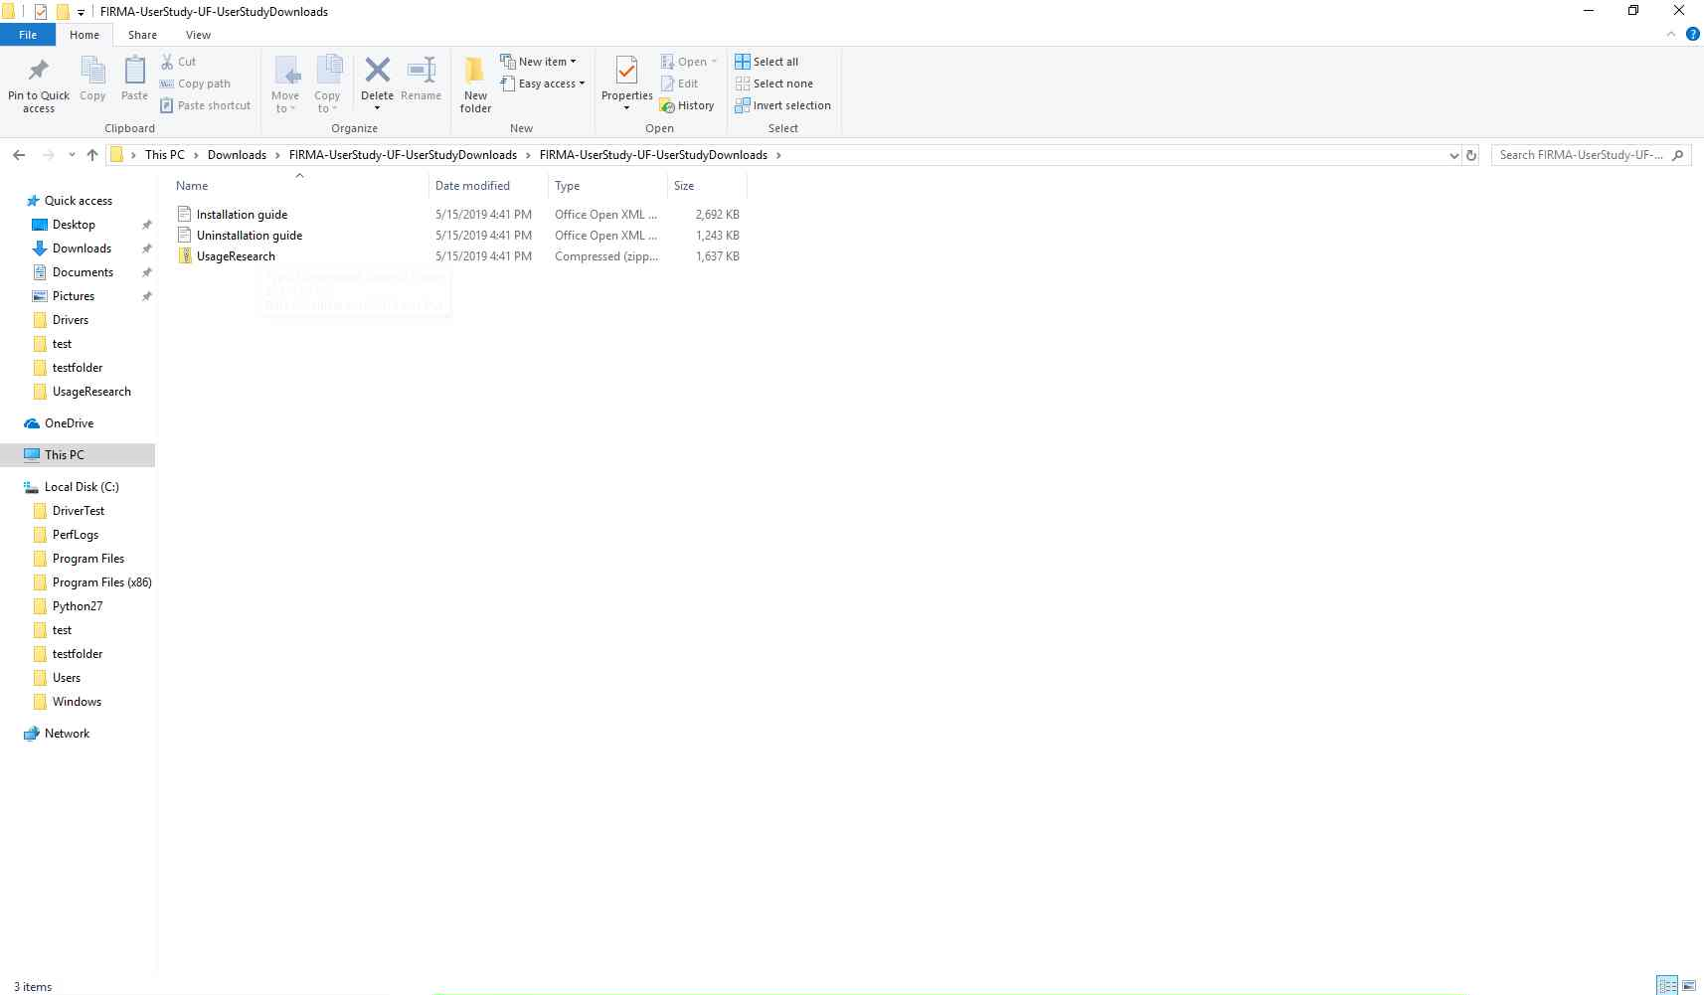

Step 7: All necessary files are downloaded now. Begin with installation

Installation:

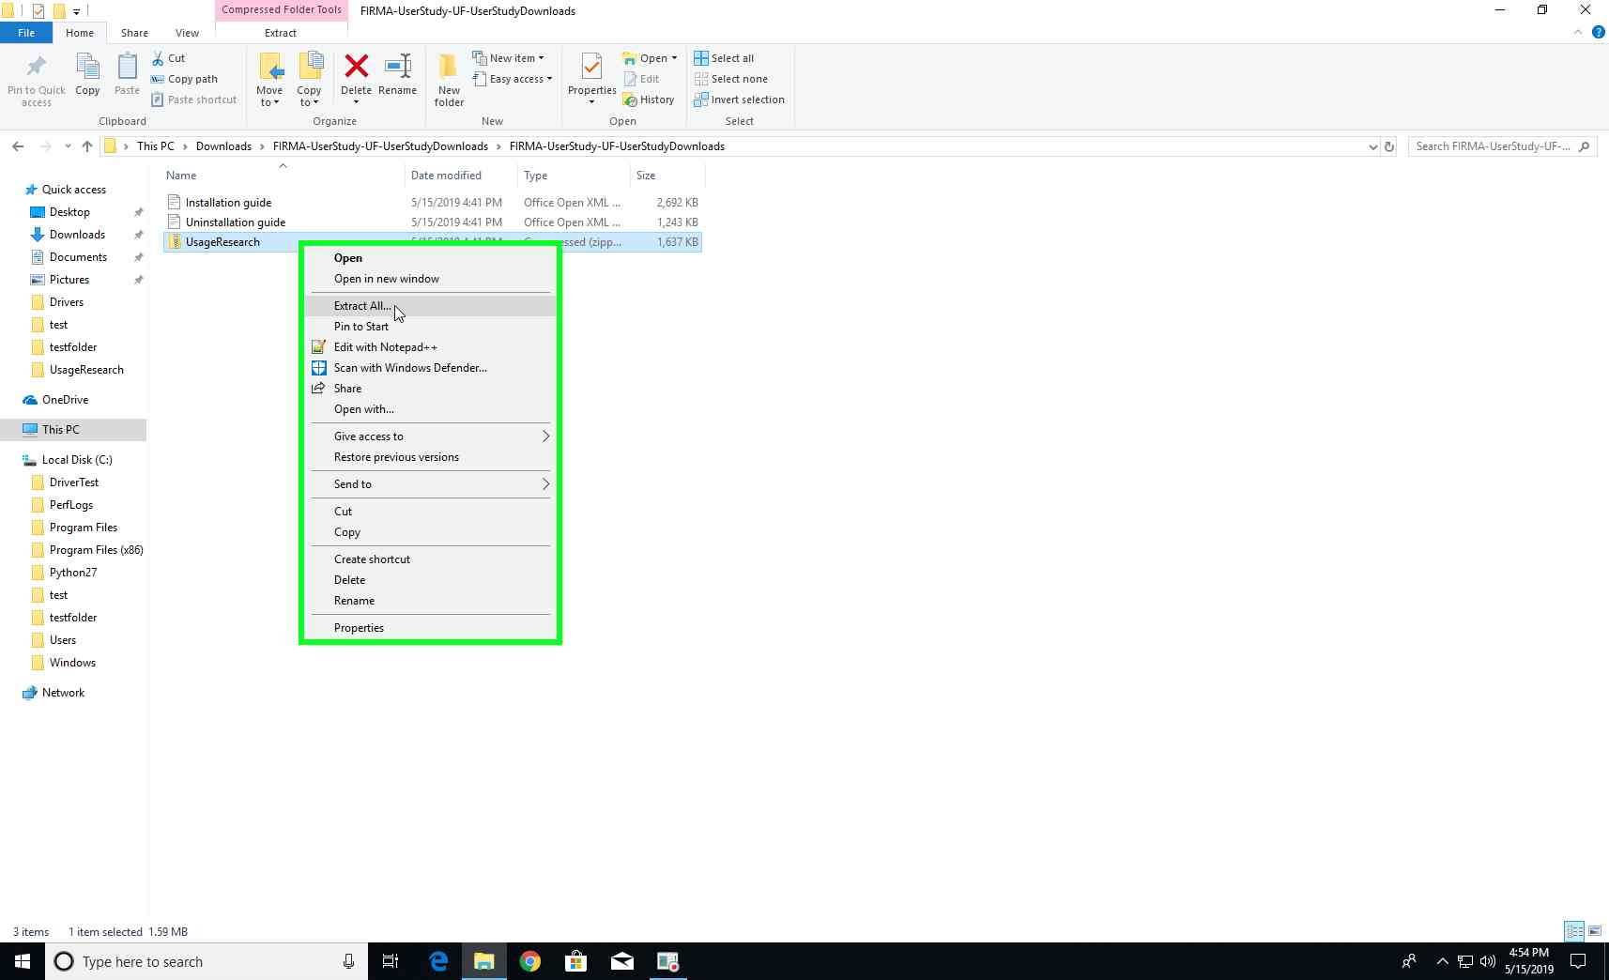

Step 1: User right click on "UsageResearch.zip" and select "Extract All"

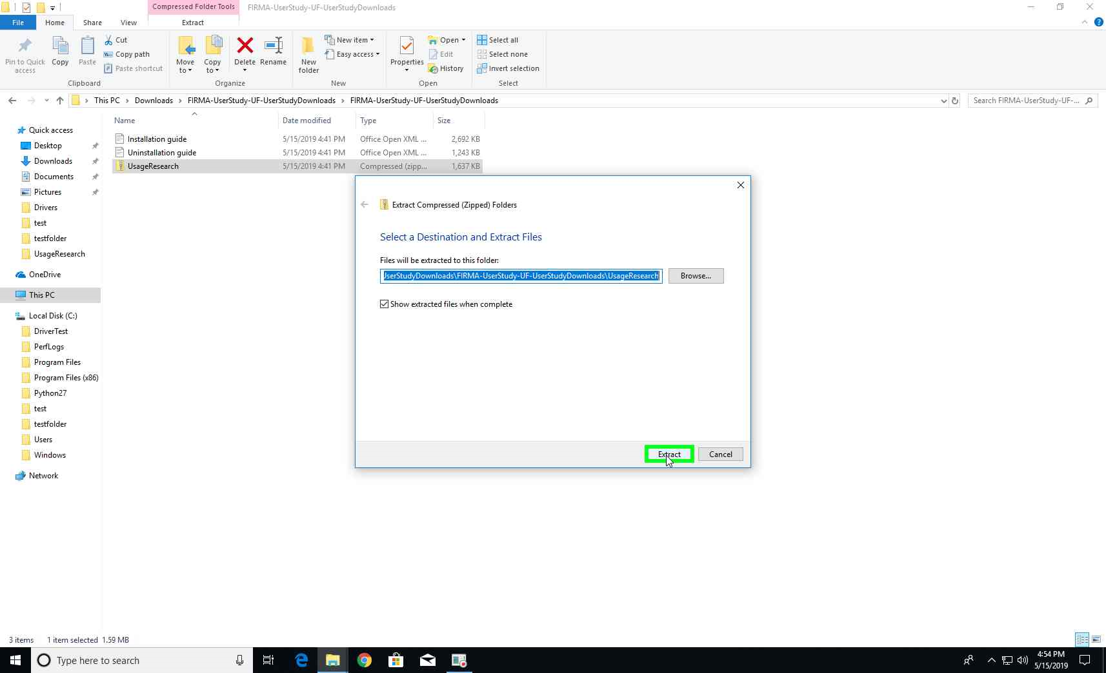

Step 2: Choose a folder where the contents can be extracted

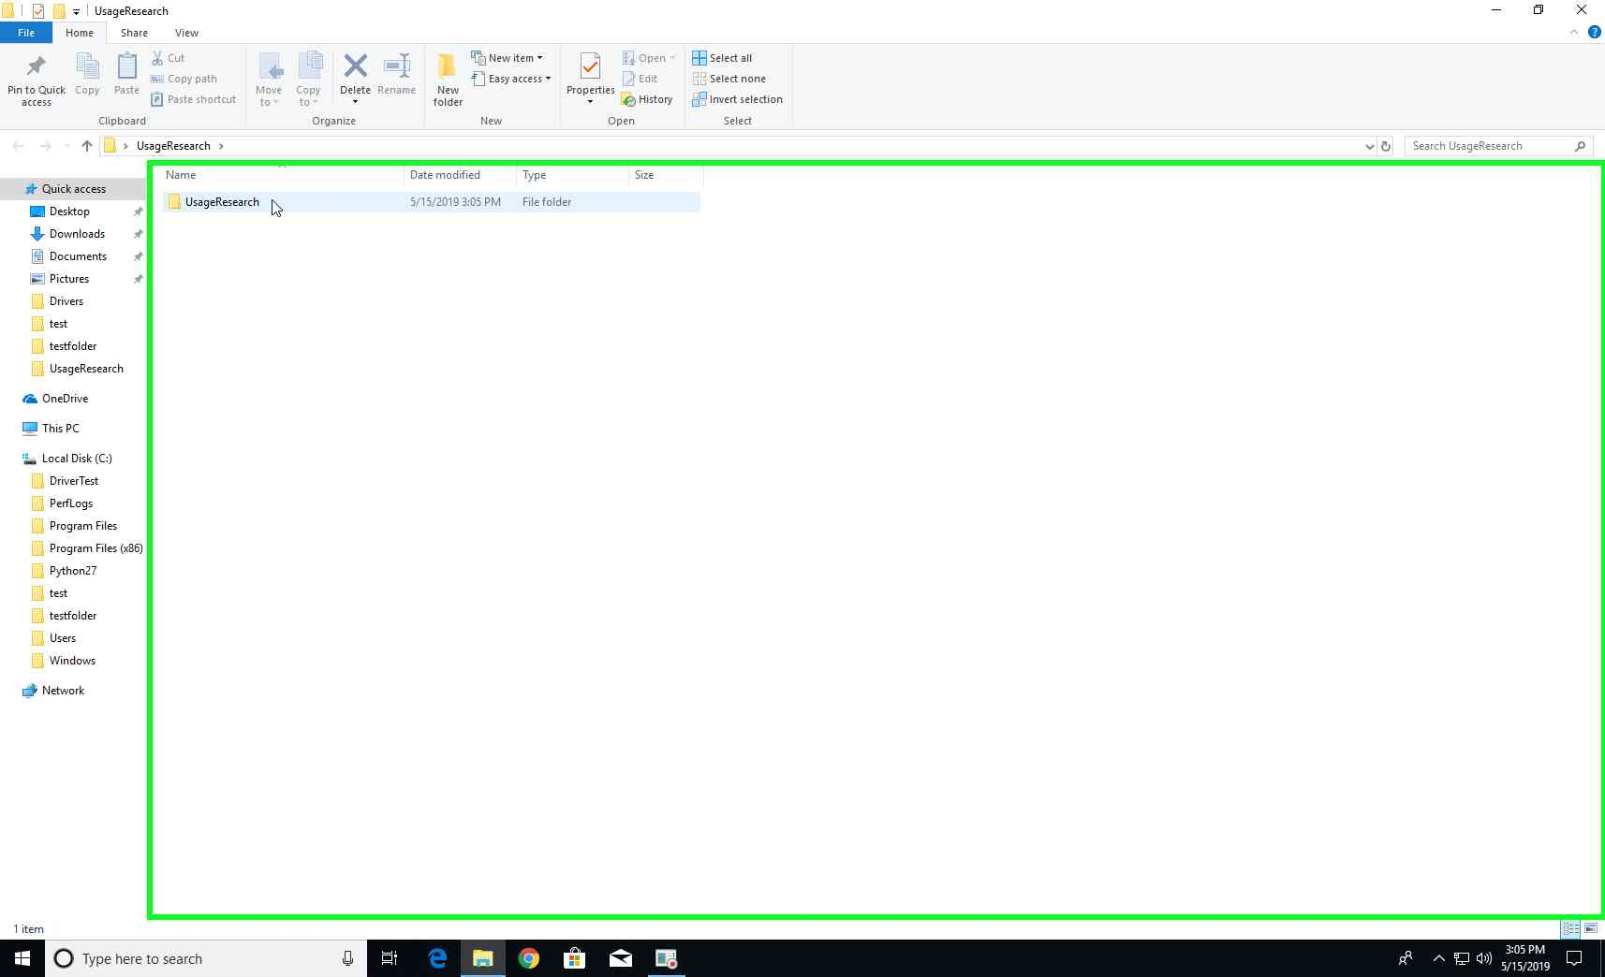

Step 3: On successfully extracting the installer, open the folder

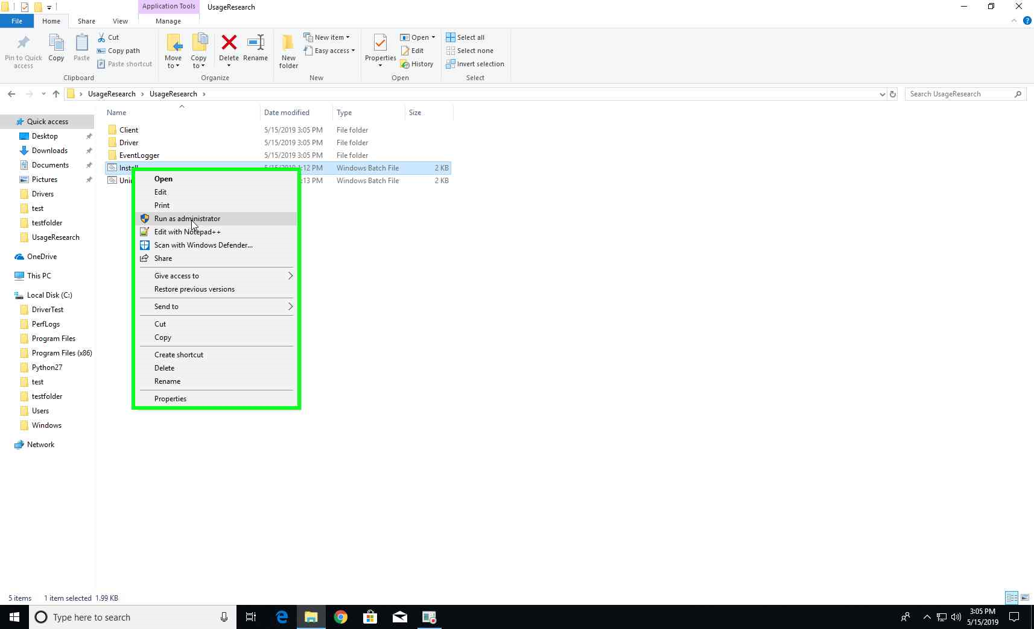

Step 4: Right-click on Install.bat and select “Run as Administrator”

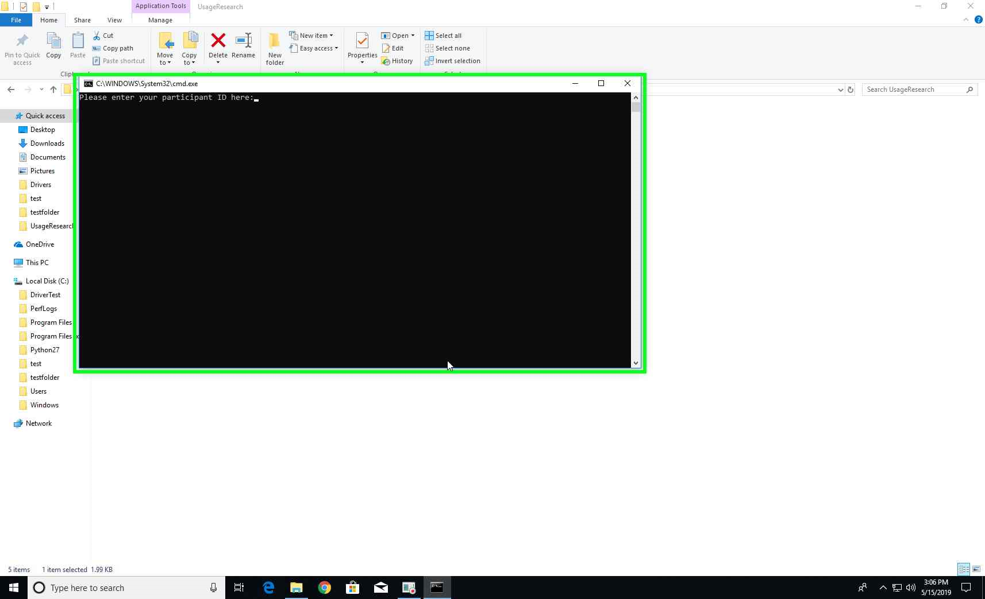

Step 5: A prompt is shown to enter Participant-ID, Name and E-mail

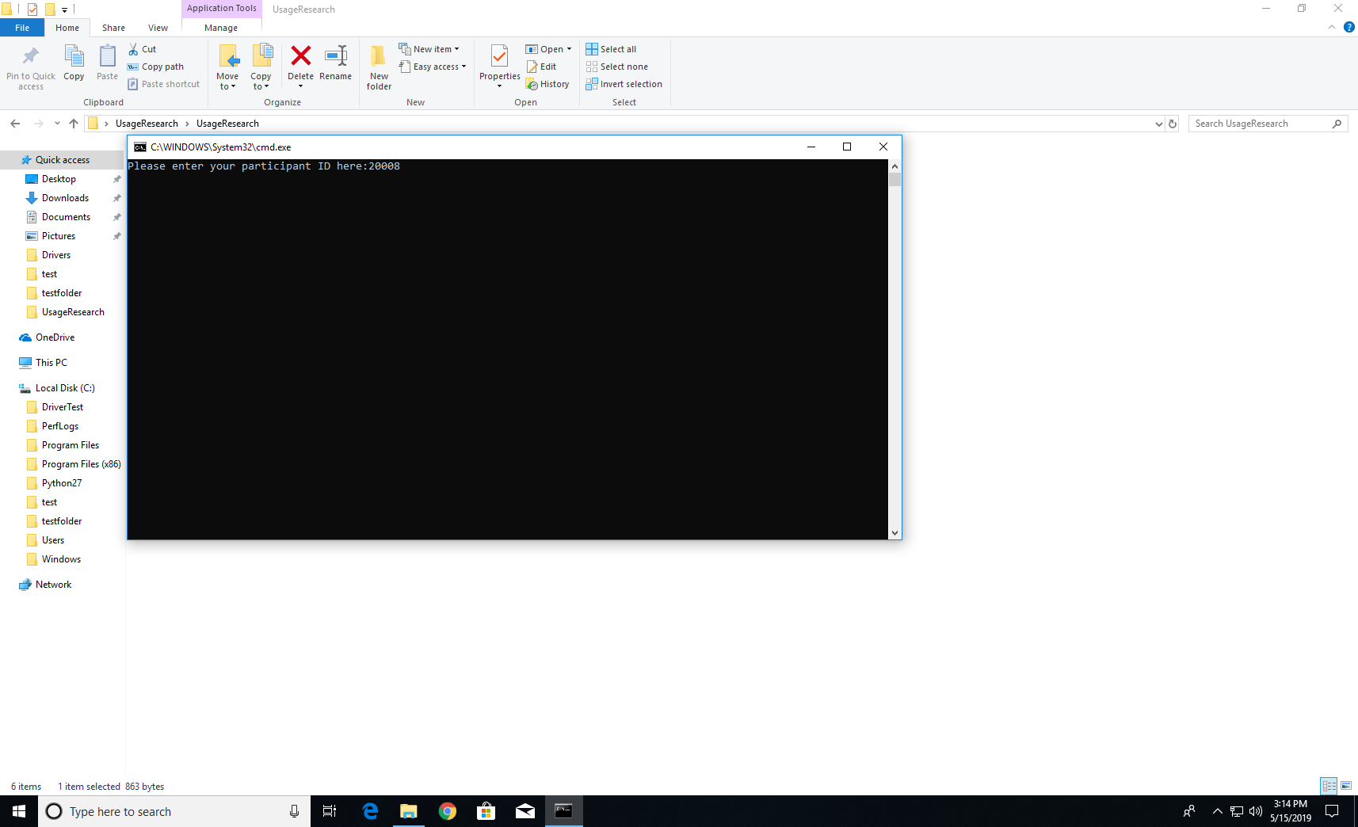

Step 6: Enter the Participant-ID assigned to you

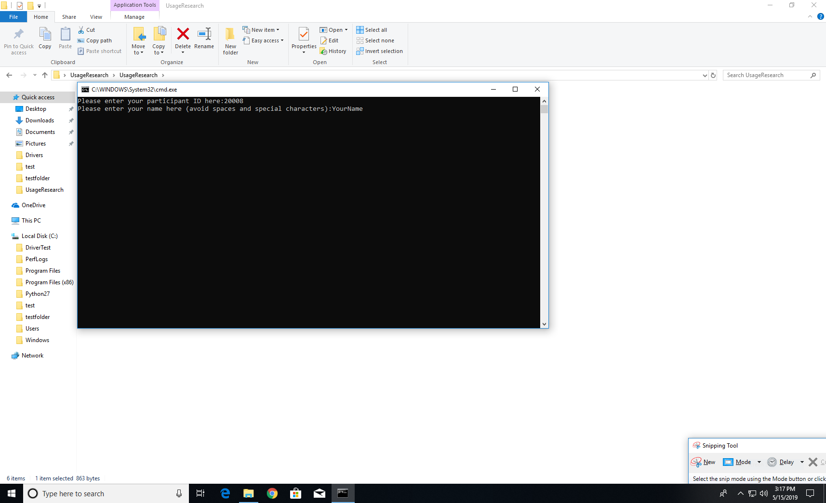

Step 7: Enter Participant name

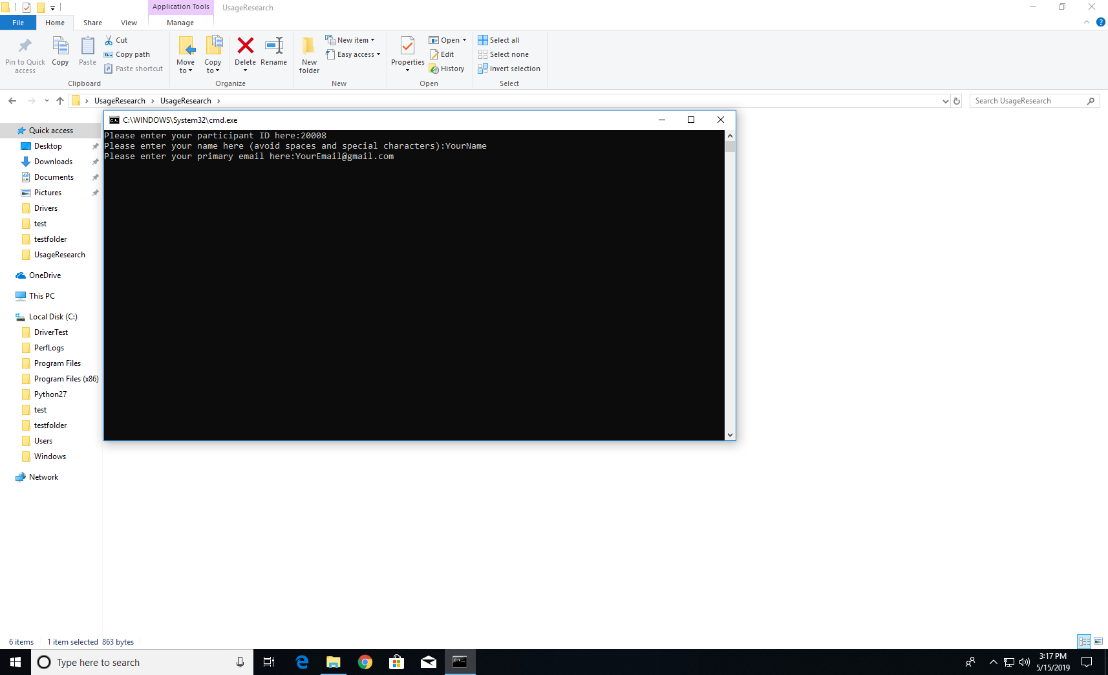

Step 8: Enter Participant E-mail

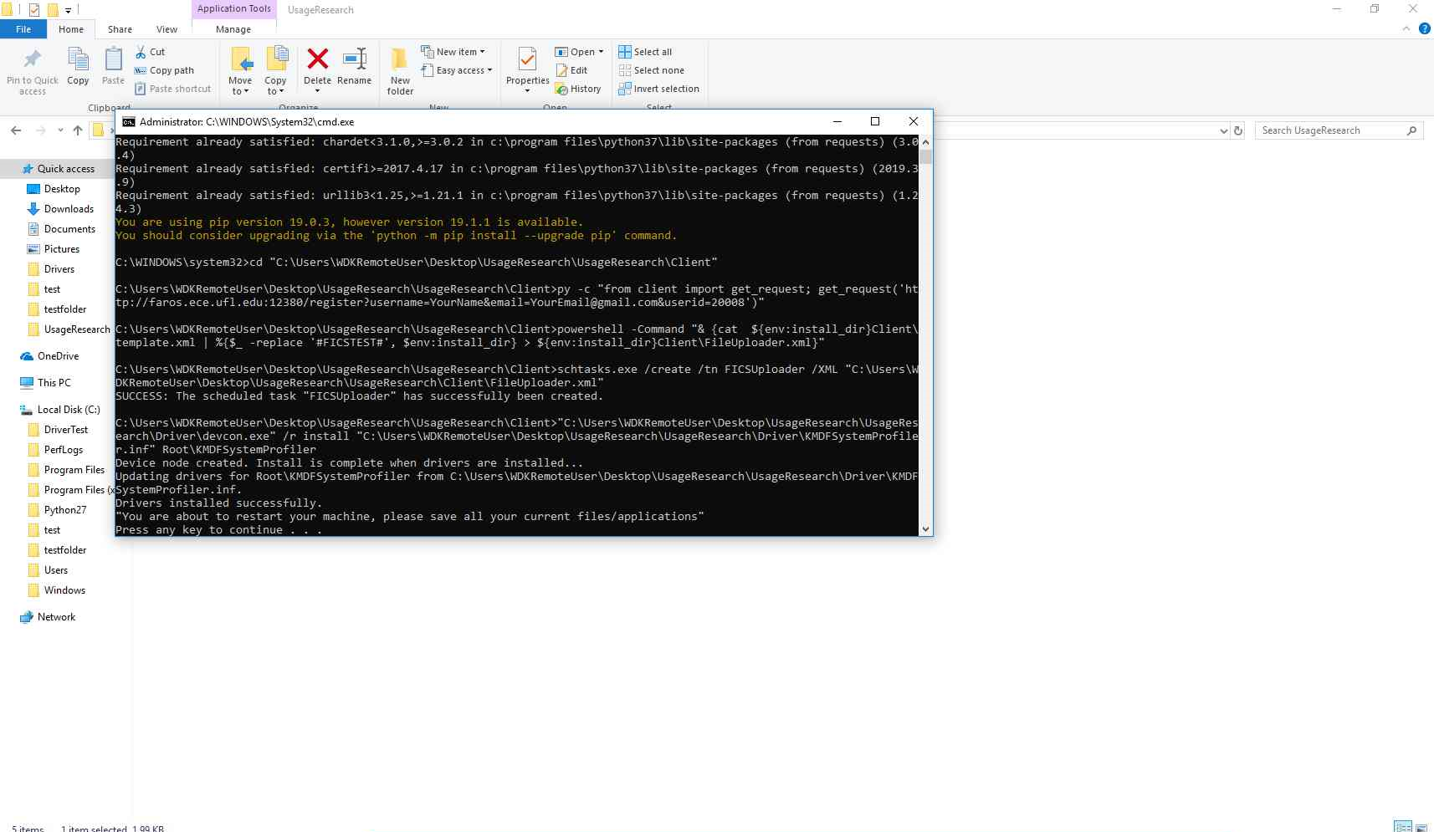

Step 9: All necessary tools are installed. Please hit enter to complete installation. The system goes for a reboot